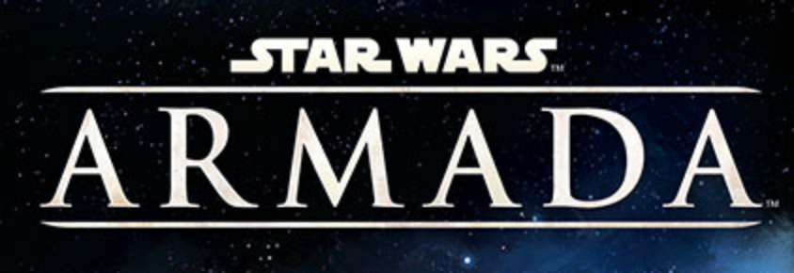
STATION ASSAULT
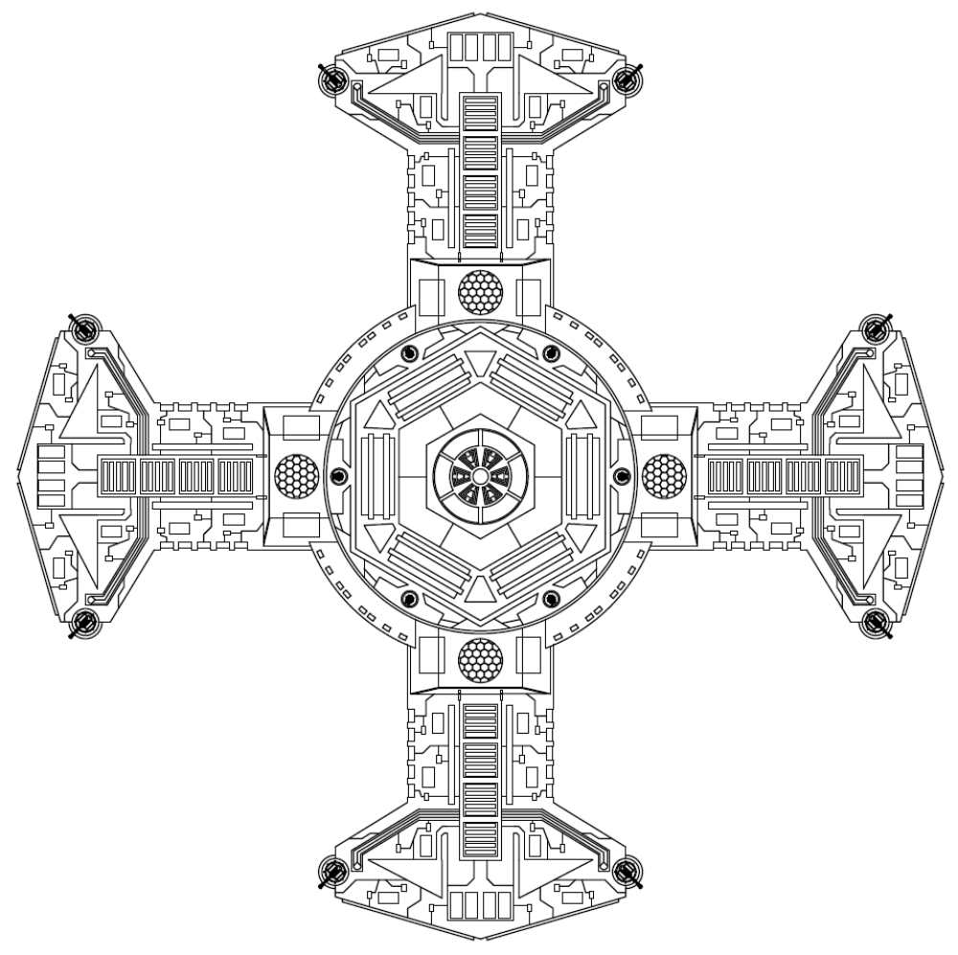

Printer Friendly
Version 0.1

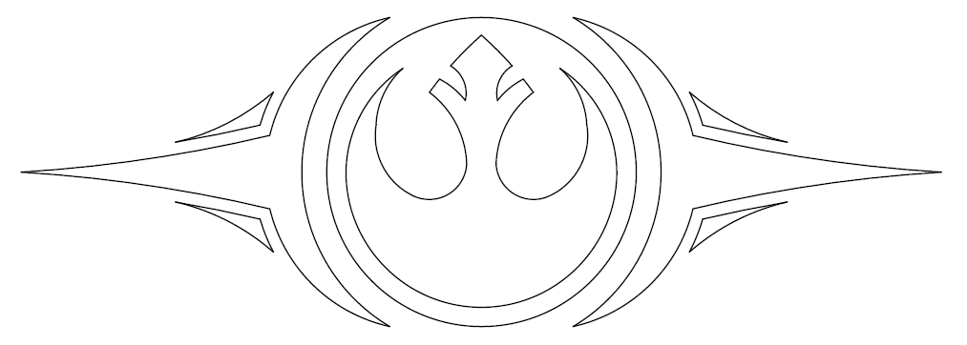
Once more our galaxy is plunged into darkness. For millennia the Republic stood as a beacon against that darkness. It insured a civilization of peace, justice, and liberty for all beings. That beacon is now threatened with extinguishment.
We know who has perpetuated this; the same ones who have done it time and again before. They who have wanted nothing more than to dominate us. To deprive us of our guardians. To tear down the liberties we have treasured. To strip us of all we hold dear.
In these dark times a call has always gone out. A call answered by our fore bearers without hesitation or remorse. A call answered with blood and tears to the last full measure. Who now will heed this call? Who will rise with me and take back what is rightfully ours? Who will rise... For Justice! For Freedom! FOR THE REPUBLIC!
Rebel Call
- Admiral Quar Wrunsh

Hello Commander. It gladdens me to know you are still well. We have lost so many in our campaign to restore the Republic; losing an officer of your caliber would be unacceptable.
I'm afraid that I must ask to put you in harms way once again though. Our intelligence network has informed us of a new imperial station in the Thesme Sector. It is a smaller modular station which was assembled quickly. As you can imagine its location poses an imminent risk to our operations in the area, and we need that base wiped out immediately. An Imperial response will be rapid and brutal, so you will have little time to complete this task. Fleet command will provide you with whatever resources they can. Good luck, and may the force be with you.
- Mon Mothma

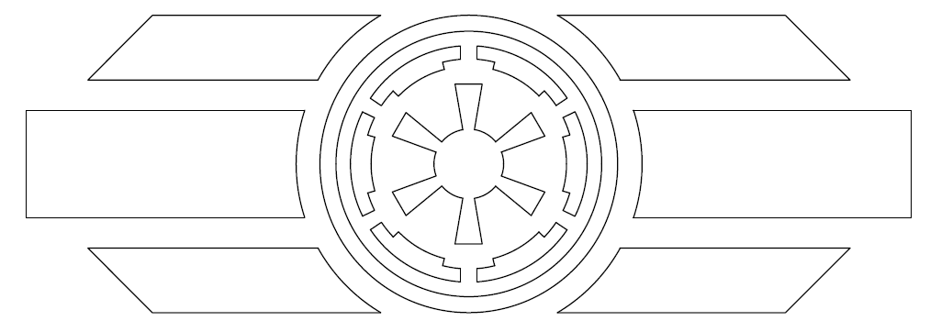
Order. We must never forget that our mandate is to bring order to a chaotic universe. Me must not allow those that would divide us to prevail. It is through unity that we find strength. It is through strength that we will build a better future.
Our beloved Emperor saw us through the chaos of the Clone Wars when the Separatist would have torn our civilization in twain. They did not succeed, nor will any movement that wishes for the division of that which so many of us have fought and died to remain whole.
Remember your Oaths, men. Together we are a mountain on which any wave of change will break. We are legion. We are loyal. We are United. We are eternal. We are the Empire
Loyalty to the Oath
- High Minister Pak Olem

Commander; your reputation precedes you. A reputation however means nothing without results. Successfully completing your next assignment would cement your reputation, and go far in advancing you within the fleet ranks. Of course I don't have to remind you of the cost for failure.
Now for the task at hand; the Rebellion has a small platform station that they have been randomly moving around the Belderone Sector. The Emperor wants it destroyed. Our analysts have pinpointed its next most likely location. You will take a small fleet there and vaporize it immediately. We expect this operation to be handled swiftly and efficiently. Nothing less will be tolerated.
- Grand Moff Tarkin

RULES

Station Assault is a Solo Module for Star Wars: Armada. Your sole objective is to Defeat the enemy Station by destroying all four of its platforms within 8 rounds. Turns will alternate between the player and Station. The player always goes first.

Components:
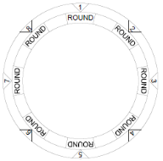
Round Tile
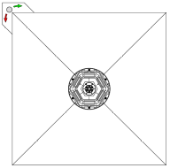
Station Core Tile
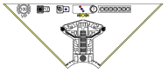
Platform Tile

Setup:
First, place the Round Tile on the play area opposite the deployment zone. It should be equidistant from the three sides of the board.

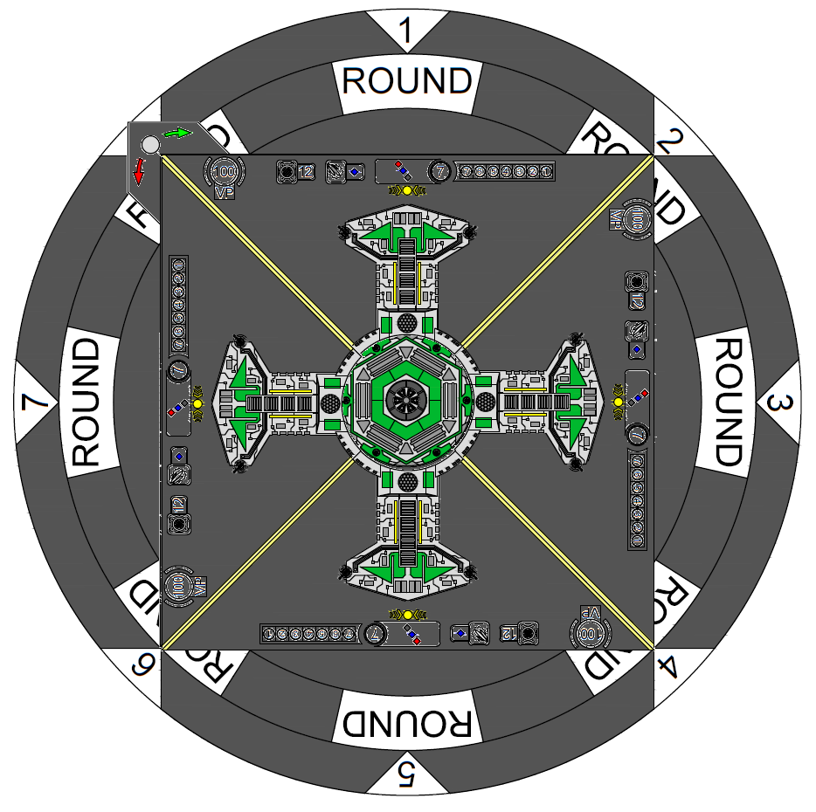
Next place the Station Core, and platforms on top of the Round Tile. You may choose to place matching platform tiles together, or randomly select tiles for an unique encounter.

Place other obstacles as per standard rules.

Targeting Cards:
At the beginning of the game, shuffle the Targeting Deck. At the start of each Station turn, draw a new targeting card and check to see if your ships are within the stations range. If so, the station will follow the text written on the targeting card*. If not, the Station will draw a command token, and resolve it as soon as it is able.

*Note: Targeting Priority is as follows – Card > Most Damaged Ship > Smallest Ship > Closest Ship. If more than one ship meets these criteria, choose a target randomly.

Example: A Swarm of 5 corvettes ends their turn within range. The card says to target the ship with most upgrades, but all are unmodified. None have been damaged yet. They are of equal size and at equal distance. They player will choose one of his ships at random to be the initial target.

Turn Structure:
1: Player Turn – play as in standard rules
2: Station Turn
- Draw new Targeting Card
- Fire twice; once from 2 separate hull zones, at 2 separate targets unless a card directs otherwise.
- Rotate the station to the next Round marker on the Round Tile.

Scoring:
At the end of the Eighth round the player will total their score. Each defeated platform has a victory point total listed on its upper right side.

If all platforms are destroyed within the 8 rounds, the player receives an addition 100 Victory Points.

After adding the Victory Points from the defeated station, the player will subtract from that total the point cost of each lost unit, Including upgrades.

If all ships are lost, the player subtracts an additional 100 Victory Points.

Objectives:
*Not Available at this Time*
Commanders:
*Not Available at this Time*
Fighters:
*Not Available at this Time*

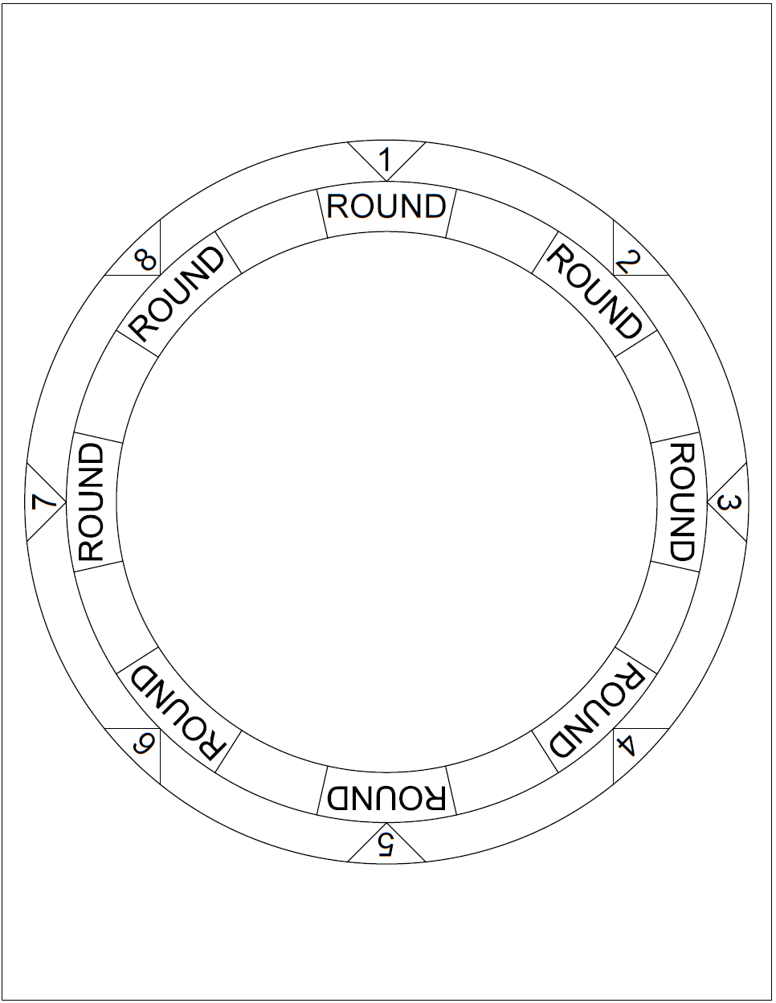
Round Dial
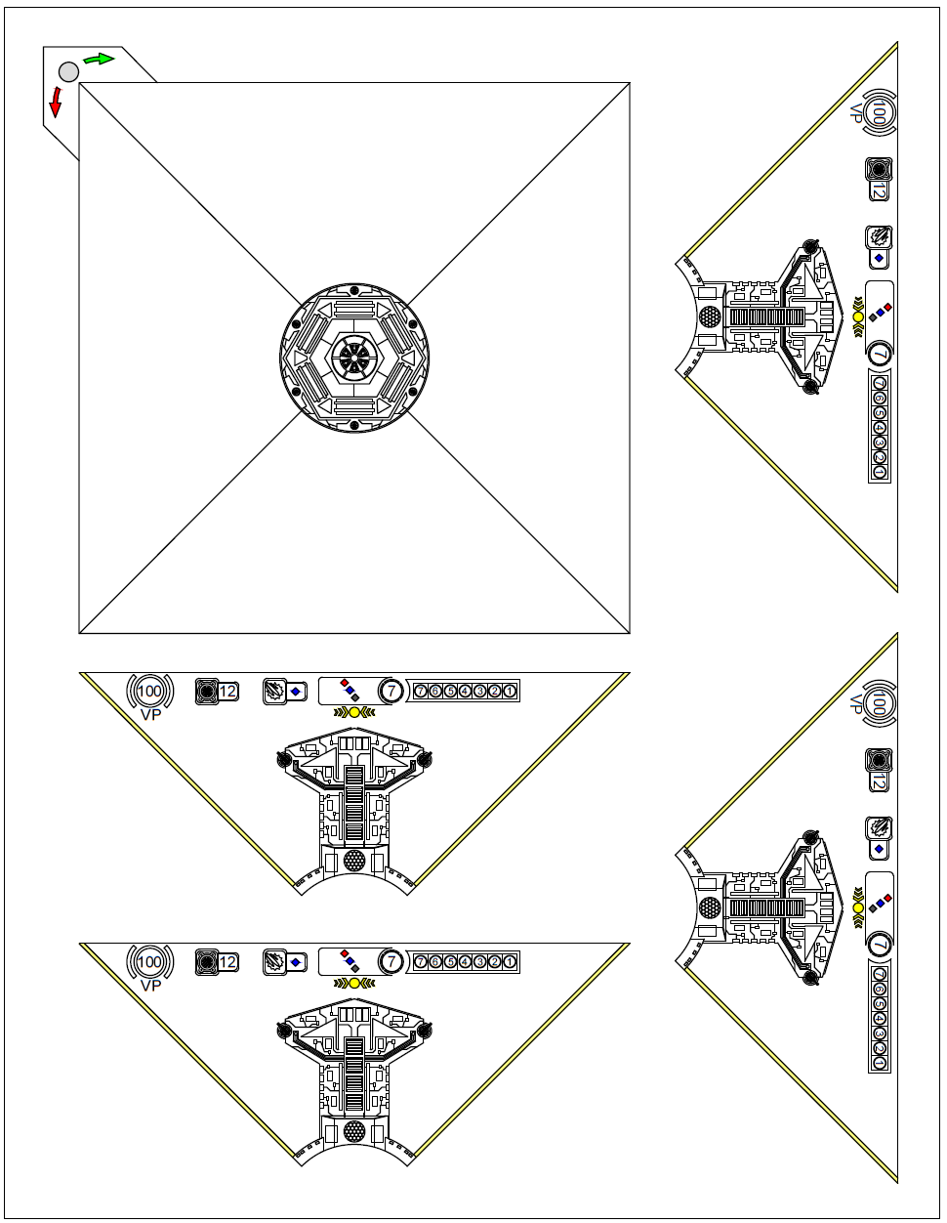
QR-E Platform Station
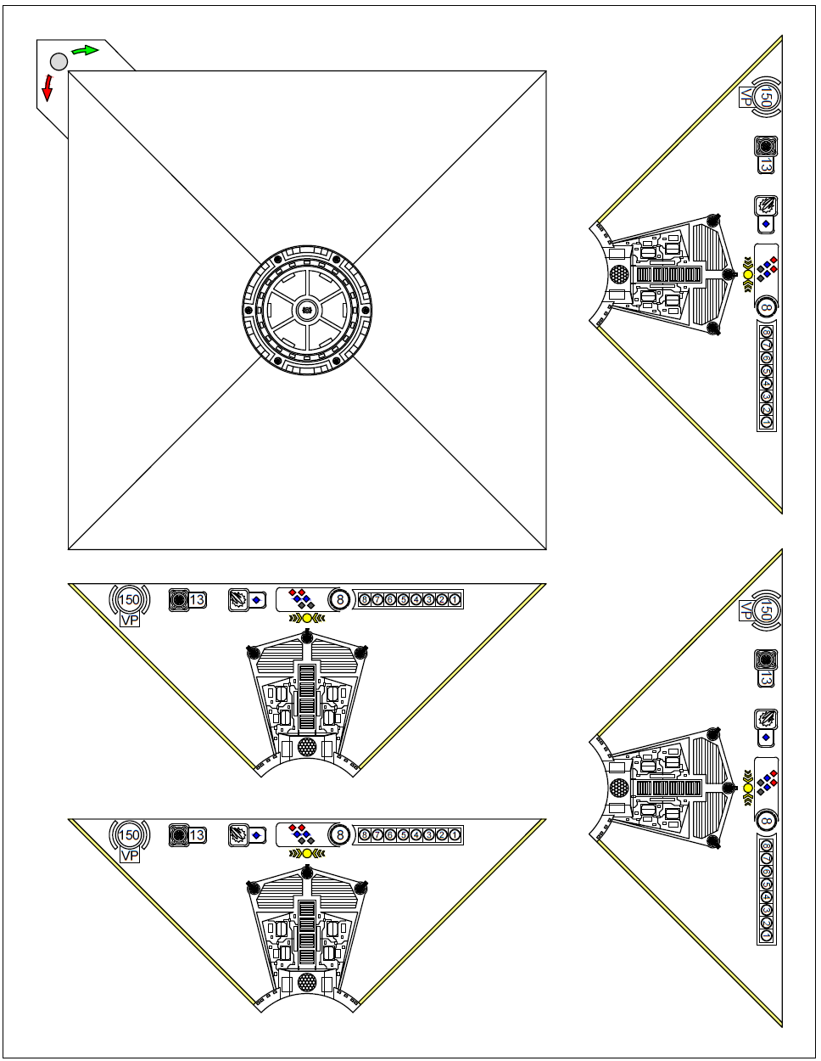
QR-M Platform Station
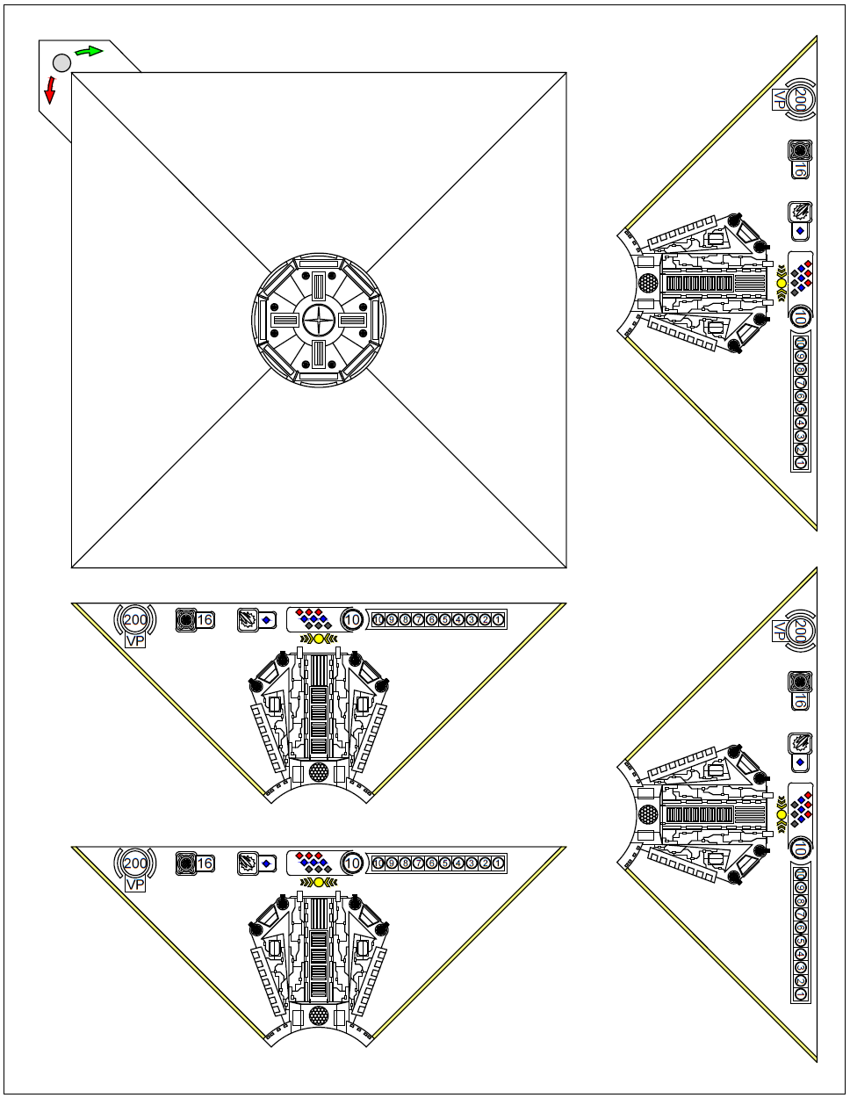
QR-H Platform Station
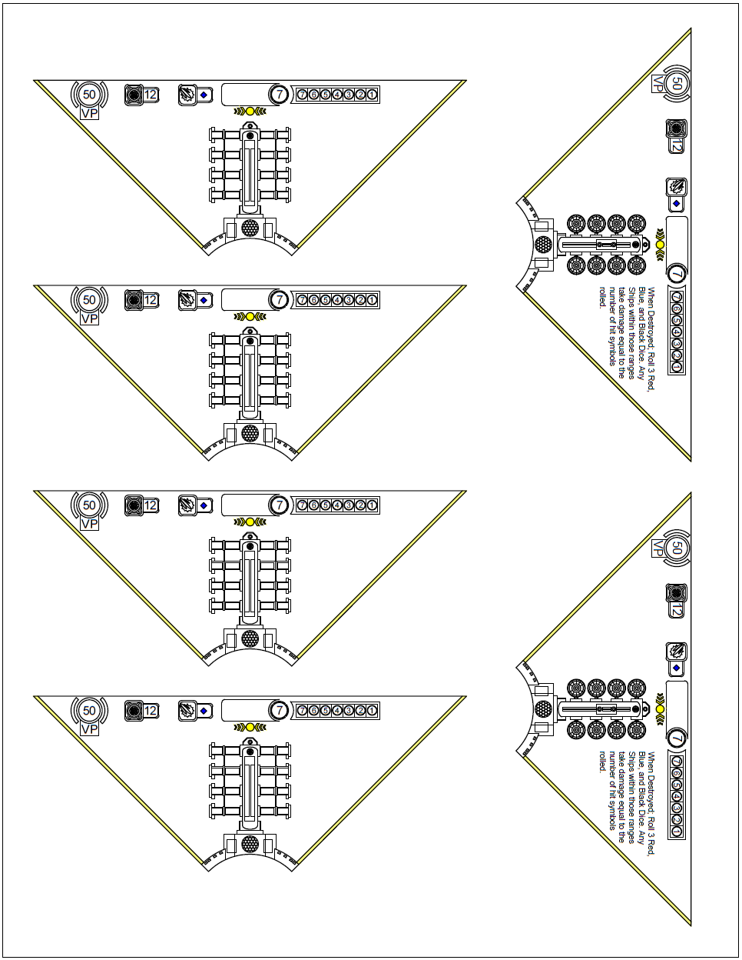
QR-S & T Platforms
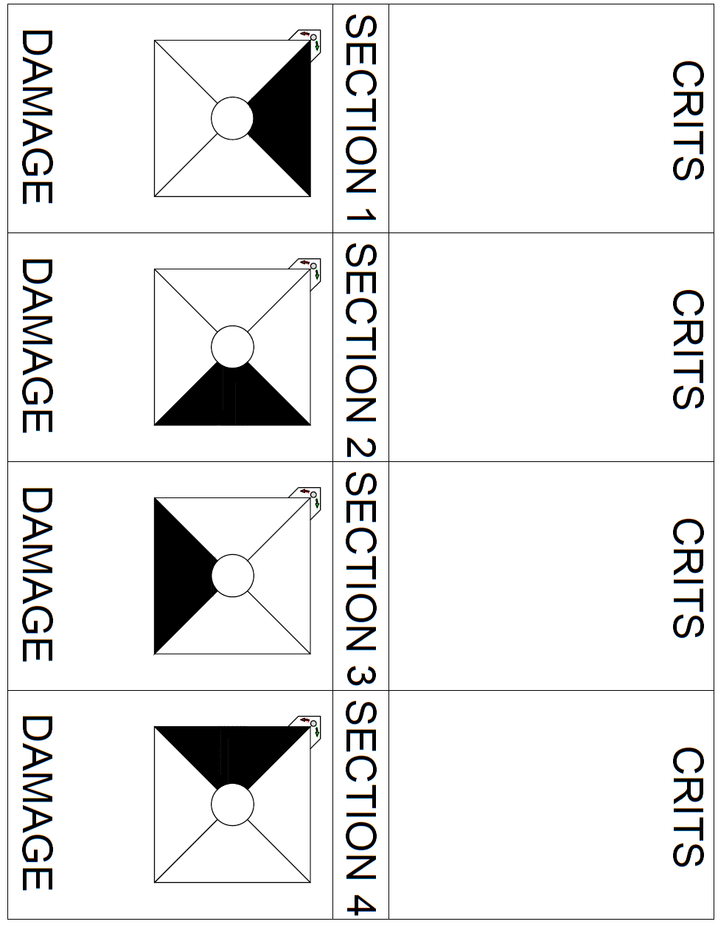
Damage Tracker
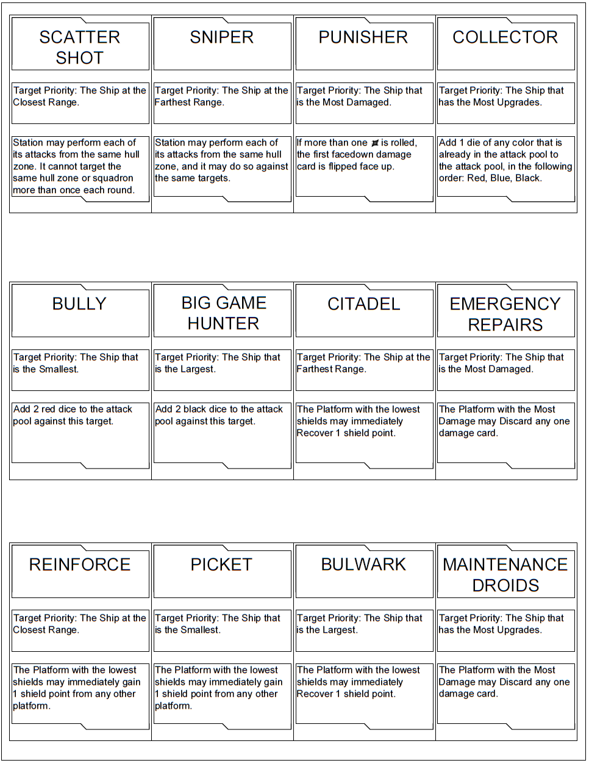
Targeting Priority Cards

